**Question 1: Data Analysis (Pie Chart - Revenue Distribution of a Company)**

**Directions:** The following question is based on the pie chart representing the **revenue distribution of a company** across different product categories.

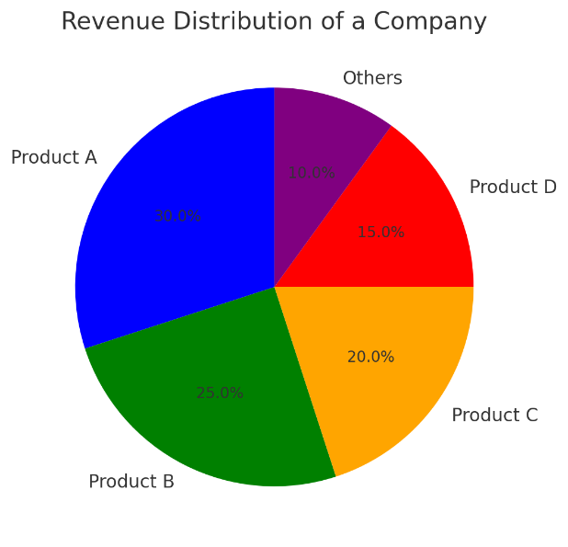

The company generates revenue from **Product A, Product B, Product C, Product D, and Other Products**. The chart shows the percentage share of each product in total revenue.

**Question:**

If the company's total revenue for the year was **$500 million**, how much revenue did **Product B** generate?

Options:

* **$100 million**
* **$125 million** ✅
* **$150 million**
* **$175 million**

**Answer & Explanation:**

Product B accounts for **25%** of the total revenue.

Revenue=25100×500=125 millionRevenue = \frac{25}{100} \times 500 = 125 \text{ million}

Thus, the correct answer is **$125 million**.

**Question 2: Data Structures (Cloud Server Stack Operations)**

A **cloud-based request handling system** operates using a **stack implemented with two queues**. The system must support **push operations in O(1) time**.

**Question:**

How many enqueue/dequeue operations are required to support the following sequence of stack operations?

push(10)

push(20)

pop()

push(30)

push(40)

pop()

Options:

* **7 enqueue 6 dequeue**
* **8 enqueue 6 dequeue** ✅
* **8 enqueue 5 dequeue**
* **7 enqueue 5 dequeue**

**Answer & Explanation:**

For implementing a stack using **two queues**, each pop operation requires **transferring elements** between the queues. In this case, the total enqueue operations are **8**, and the total dequeue operations are **6**.

**Question 3: Data Analysis (Crop Production - Bar Graph)**

**Directions:** The question is based on the given bar chart that shows the **annual crop production** in million tons for **Wheat, Rice, Corn, and Soybean**.

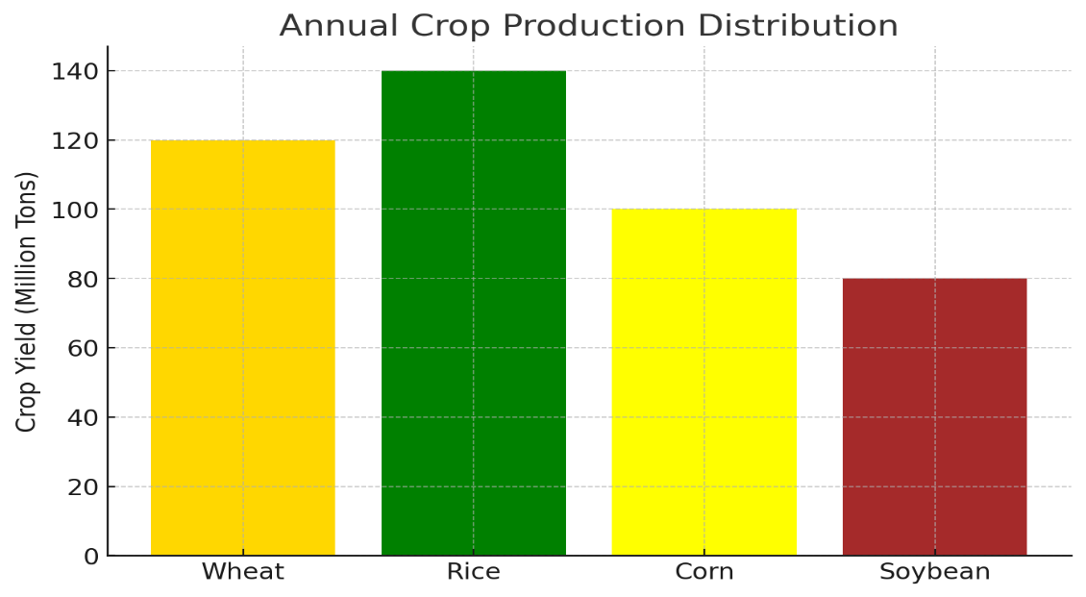

**Question:**

If a **drought** affected **Corn production** reducing its yield by **20%**, what would be the new production value for Corn?

Options:

* **80 million tons** ✅
* **90 million tons**
* **100 million tons**
* **110 million tons**

**Answer & Explanation:**

The initial production of Corn was **100 million tons**. A **20% reduction** means:

NewProduction=100−(20100×100)=80 million tonsNew Production = 100 - \left( \frac{20}{100} \times 100 \right) = 80 \text{ million tons}

Thus, the correct answer is **80 million tons**.

**Question 4: Numerical Ability (Football Goal Scoring Statistics)**

Three players, **X, Y, and Z**, participated in a football league. The ratio of the number of goals by **X to Y** and the ratio of the number of goals by **Z to Y** is **each 4:3**.

They scored a **total of 400 goals** in the season.

**Question:**

How many goals did **Player X** score?

Options:

* **192** ✅
* **160**
* **128**
* **144**

**Answer & Explanation:**

Let the number of goals scored be in the ratio **X:Y:Z = 4:3 and Y:Z = 3:4**. This implies the combined ratio is **X:Y:Z = 16:12:9**.

Total goals scored = **400**

X=1616+12+9×400=1637×400=192X = \frac{16}{16+12+9} \times 400 = \frac{16}{37} \times 400 = 192

Thus, the correct answer is **192 goals**.

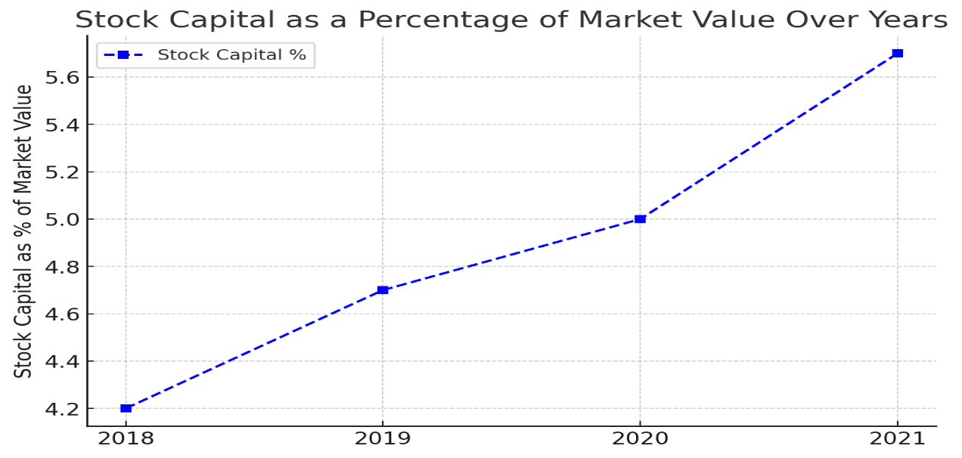

**Question 5: Financial Data (Stock Market Performance - Line Graph)**

A company’s financial team is analyzing the **stock capital as a percentage of total market value** over the past four years.

| **Year** | **2018** | **2019** | **2020** | **2021** |
| --- | --- | --- | --- | --- |
| Stock Capital ($M) | 50 | 70 | 90 | 120 |
| Market Value ($M) | 1200 | 1500 | 1800 | 2100 |

**Question:**

In which year was the **stock capital as a percentage of market value** the highest?

Options:

* **2018** ✅
* **2019**
* **2020**
* **2021**

**Answer & Explanation:**

To find the year with the highest percentage:

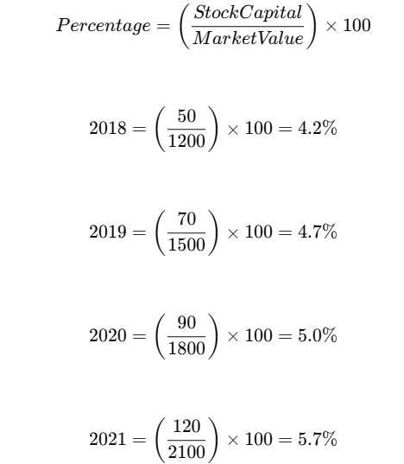

Thus, **2021 had the highest percentage**, and the correct answer is **2021**.